FILE PROCESSING SYSTEM
A file system is a method for storing and organizing computer files and the data they contain to make it easy to find and access them. File systems may use a storage device such as a hard disk or CD-ROM and involve maintaining the physical location of the files.

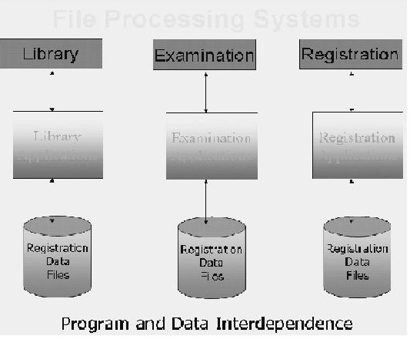

Characteristics of File Processing System
Here is the list of some important characteristics of file processing system:
• It is a group of files storing data of an organization.
• Each file is independent from one another.
• Each file is called a flat file.
• Each file contained and processed information for one specific function, such as accounting or inventory.
• Files are designed by using programs written in programming languages such as COBOL (common business oriented language), C, C++.
• The physical implementation and access procedures are written into database application; therefore, physical changes resulted in intensive rework on the part of the programmer.
• As systems became more complex, file processing systems offered little flexibility, presented many limitations, and were difficult to maintain.

Limitations of the File Processing System I File-Based Approach
- Separated and Isolated Data
- Duplication of data
- Data Dependence
- Difficulty in representing data from the user's view
- Data Inflexibility
- Incompatible file formats
- Data Security
- Transactional Problems
- Concurrency problems
- Poor data modeling of real world

