LAND USE PATTERN
LAND USE MODELS
- Burgess Model (1925)
This model is based on the idea that land values are highest in the center of a town or city. This is because competition is high in the central parts of the settlement. This leads to high-rise, high-density buildings being found near the Central Business District (CBD), with low-density, sparse developments on the edge of the town or city.
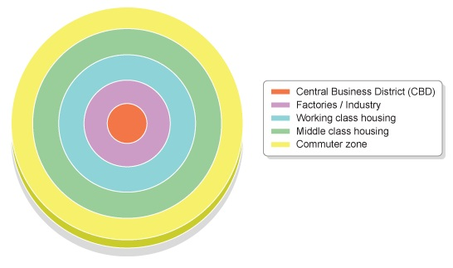
However, there are limits to the Burgess model:
- The model is now quite old and was developed before the advent of mass car ownership.
- New working and housing trends have emerged since the model was developed. Many people now choose to live and work outside the city on the urban fringe - a phenomenon that is not reflected in the Burgess model.
- Every city is different. There is no such thing as a typical city.

- Hoyt model
This is based on the circles on the Burgess model, but adds sectors of similar land uses concentrated in parts of the city. Notice how some zones, e.g. the factories/industry zone, radiate out from the CBD. This is probably following the line of a main road or a railway.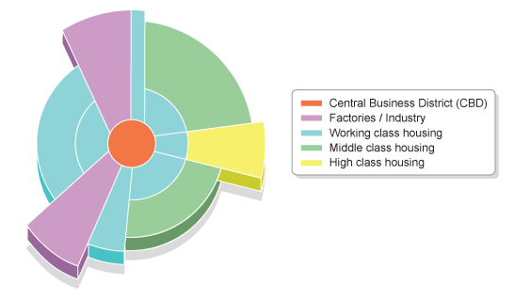
CBD
The land in urban areas is used for many different purposes:
- leisure and recreation - may include open land, e.g. parks or built facilities such as sports centers
- residential - the building of houses and flats
- transport - road and rail networks, stations and airports
- business and commerce - the building of offices, shops and banks
- industry - factories, warehouses and small production centers
The CBD in the city center is where most business and commerce is located.

The CBD is located in the center because it is:
- a central location for road/railways to converge
- the most accessible location for workers
- accessible to most people for shops and businesses

