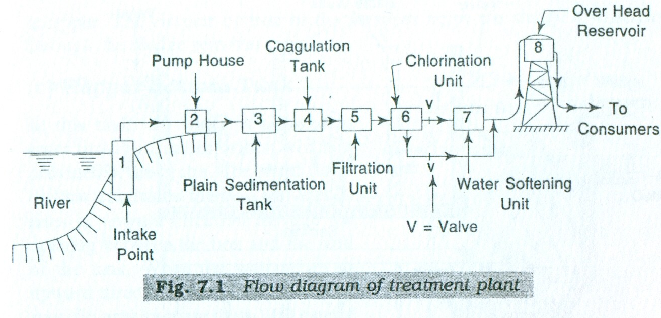

Processes for drinking water treatment
A combination selected from the following processes is used for municipal drinking water treatment worldwide:
- Pre-chlorination - for algae control and arresting any biological growth
- Aeration - along with pre-chlorination for removal of dissolved iron and manganese
- Coagulation - for flocculation
- Coagulant aids, also known as polyelectrolytes - to improve coagulation and for thicker floc formation
- Sedimentation - for solids separation, that is, removal of suspended solids trapped in the floc
- Filtration - removing particles from water
- Desalination - Process of removing salt from the water
- Disinfection - for killing bacteria.

Importance of Water Treatment

Treatment of water is so important that we can avoid many possible water borne diseases like cholera, typhoid, jaundice and so on. It's true that water borne infections are responsible for more than 80% of the diseases in all over the world. Whenever there is contamination of drinking water sources and water logging after rain there is in an outbreak of infection.
