Shapes of Cities

But why?
Here are some attempts to explain and categorize the differences.

THE COSMIC (OR HOLY) CITY
This city reflects beliefs about the universal and social order. Characteristic design features are a monumental axis – a temple, cathedral or citadel, for example – some dominant landmarks and reliance on a regular grid. Baroque ‘ideal city’ plans tend to fit this model.¹

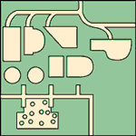
THE PRACTICAL CITY
The design of colonial and company towns and the grid cities of the US are motivated by practicality. A city, according to this model, is made up of small autonomous parts linked together into a great machine which has clearly differentiated functions and motions.¹

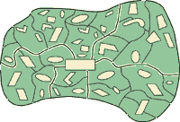
THE ORGANIC (OR WALKING) CITY
This city is a living thing, evolving in a natural way to fit the landscape. It has a definite boundary, an optimum size, and a cohesive individual internal structure. All destinations can be reached by foot in 30 minutes, and it is rarely more than five kilometres wide. This model is typical of medieval towns, and can still be found in the centres of older European and North African and Asian cities. ^{1,2}
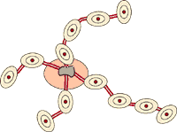
THE TRANSIT CITY
At the end of the nineteenth century trains and trams allowed cities to expand outwards. Trains create sub-centres at train stations and trams generate development along their routes. The transit city tends to be a medium density, mixed-use city, with a dominant focus at the city core. These cities now spread 20 to 30 kilometres across.²

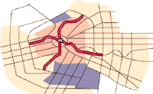
AUTOMOBILE CITY
The growth of car use after 1945 made it possible to expand in all directions. Low-density suburbs house commuters, with separate zones for industry and commerce created by planners. The city is decentralized and dispersed and is typically 50 km or more wide. This model is very dominant in the world today.²

FUTURE CITY?
This could be more compact in nature, with mixed use of residential, commercial and small-scale industry. Apart from the city centre there would be sub-centres or nuclei, linked by an extensive and efficient network of public transit, reducing the need for car ownership and freeing up space for green amenities.²
Sources:
1 Kevin Lynch in Good City Form, 1981.
2 Adapted from Peter Newman, ‘The Car, the Community and Quality of Life’, Seminar Paper 1993, quoted in Joan Roelof’s Greening Cities.

