Sketch the hydrological cycle and discuss all the processes involved in it.
Environment:

The surroundings or conditions in which a person, animal, or plant lives or operates.
OR
The natural world, as a whole or in a particular geographical area, especially as affected by human activity.

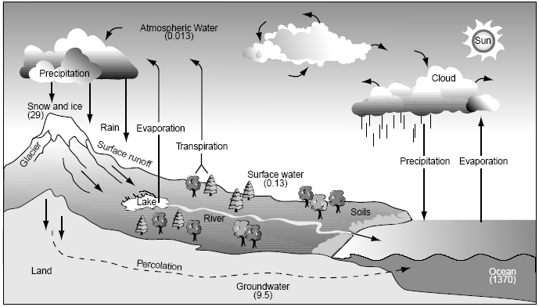

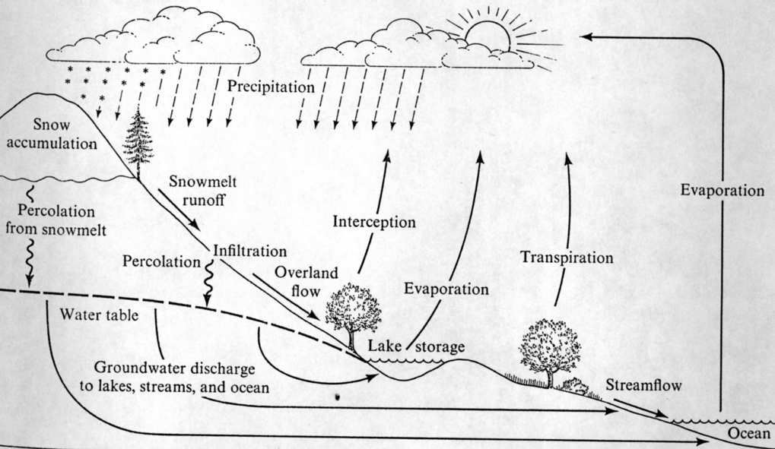

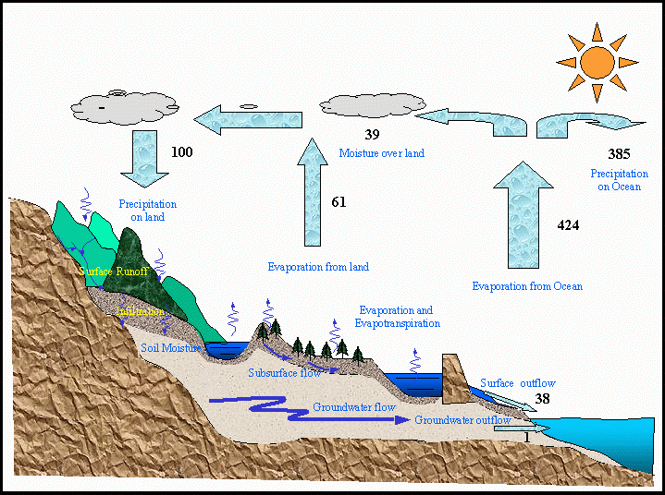
Ten processes of hydrologic cycle
- Evaporation: Water evaporates from oceans and land surface to become part of atmosphere (water vapor).
2. Precipitation: Water vapor is lifted and transported in the atmosphere until it condenses and precipitates on the land or oceans.
3. Interception: Precipitated water intercepted by vegetation
4. Overland flow: Precipitated water overflowing on ground surface
5. Infiltration: Precipitated water infiltrated into ground
6. Subsurface flow: Precipitated water flowing through the soil near land surface
7. Surface runoff (stream flow): Precipitated water discharged to streams
8. Recharge: Deep percolation to water table
9. Groundwater flow: Movement of water table deeper in soil or rock strata
10. Overflow to oceans: Surface and groundwater returning to oceans

